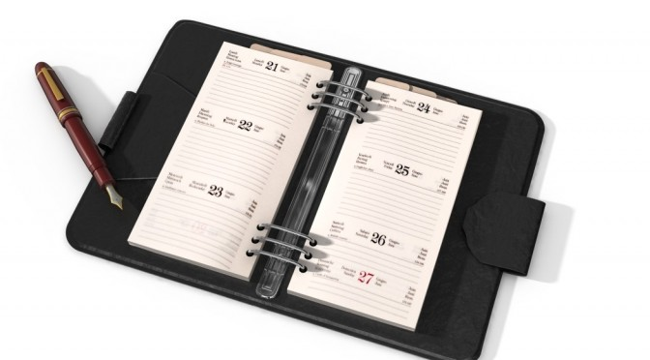
Using an Agenda
Students need a place to keep track of deadlines, appointments, and other information. Using a planner will help students to manage and remember important information. They can also enter their class schedule, a friend's number to call for homework clarification, and a detailed description of homework and due dates.

- Students are encouraged to use an agenda or calendar
  - Record Homework Assignments
  - Record dates when projects are due
  - Record dates of tests/quizzes
- Highlight important information

