Massachusetts Career Information System Website
Go to https://masscis.intocareers.org
- Click on Massachusetts Resident
- Click the 2nd white box for high school 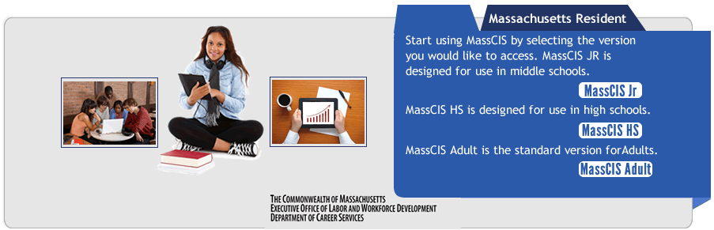
- Put in your town and zip code and sign in
- Once you have created your account, you can just log in with your user name and password.
 | Date | Task Completed | Copy in Folder
Create Portfolio
Create Log in
Learn About Myself  1.) Reality Check  2.) Career Cluster Inventory  3.) Skills | 1.)  2.)  3.) | 1.)  2.)  3.) | 1.)  2.)  3.)
Learn About Work  1.)Career Clusters  2.) Occupations  3.) Occupation sort  4.) About the Military | 1.)  2.)  3.)  4.) | 1.)  2.)  3.)  4.) | 1.)  2.)  3.)  4.)
Learn About Schools  1.)Programs of Study  2.) MA schools  3.) School sort  4.) Paying for school  5.) Financial Aid sort | 1.)  2.)  3.)  4.)  5.) | 1.)  2.)  3.)  4.)  5.) | 1.)  2.)  3.)  4.)  5.)
Learn About Employment  1.)Job search  2.) Job success | 1.)  2.) | 1.)  2.) | 1.)  2.)

