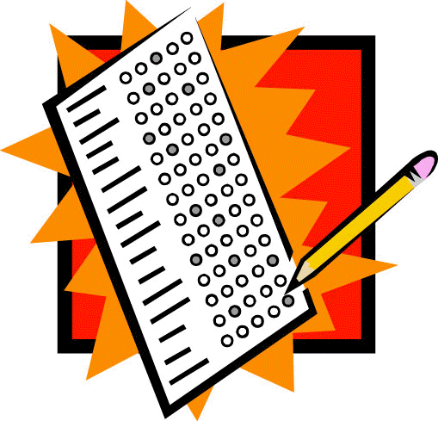
- Pay particular attention to any study guides
- Ask the teacher what to anticipate on the test
- Pay particular attention just prior to the exam
  - Closely look at the points they bring up during class
- Generate a list of possible questions for your teacher
  - Show them you are trying by having actual questions
- Review previous tests
  - SAVE your tests and quizzes
- Confer with other students
- Pay particular attention to clues
  - Things the instructor may say:
    - Saying something more than once
    - Write material on the board
    - Pauses to review notes
    - Asks the class specific questions
    - Says, “This will be on the test!”

