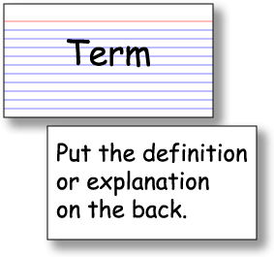

- This method of studying gives you an accurate perception of how well you know the material and forces you to think about it rather than just look it over.
- Review your notes and reading frequently, so the material is “fresh”
- As you’re reading your test or reviewing your notes, write down questions about the material.
- Keep track of any terms you need to know and make flashcards
- Try the flash card system:
- Front – write the term
- Back – write the definition or description
- Shuffle cards
- Look at card on the top:
  - Try to answer the question or explain the term
  - If you know it, GREAT! – Put it in the “know” pile
  - If you don’t, look at the answer and put it in the
“do not know” pile.
- Proceed through the deck of cards until you know all of the information.

