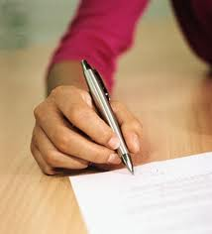

- Find out what the question is asking: If the question says compare two items, do not just explain the two.
- Make a quick outline when test time has begun. Write down important facts and information
- Get to the answer right away. Don’t waste time with introductions unless you can tie them into the answer.
- Bring out facts and ideas at the beginning. Don’t wait until the end of the essay.
- Write clearly and with a pen (unless otherwise instructed).
- Be brief! Don’t be wordy to try to fill up space.
- Try to write on one side of the paper. Since the ink shows through.
- Review answer for grammatical or informational mistakes.

